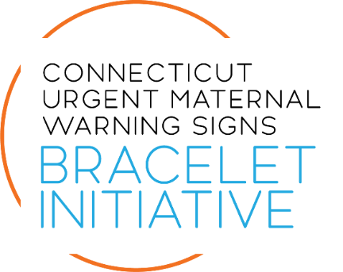
INSERT NAME OF HOSPITAL/HEALTH SYSTEM IMPLEMENTS POSTPARTUM BRACELET INITIATIVE
Postpartum patients will receive orange bracelets to be worn as a reminder to watch for pregnancy-related health problems.
LOCATION — INSERT NAME OF HOSPITAL/HEALTH SYSTEM today announced its participation in the Connecticut Urgent Maternal Warning Signs Bracelet Initiative, a statewide effort to reduce preventable pregnancy-related complications and save lives.
As part of this program, postpartum patients at [INSERT HOSPITAL/HEALTH SYSTEM NAME] will receive an orange bracelet before leaving the hospital. Patients are encouraged to wear the bracelet for 12 weeks postpartum as a reminder to monitor their health and to alert healthcare professionals and first responders that they are newly postpartum.
The bracelet is designed to promote timely recognition of urgent maternal warning signs — which are symptoms of potentially serious health complications such as eclampsia, blood clots, sepsis, cardiomyopathy, and perinatal depression. These conditions can become life-threatening if not identified and treated early.
[INSERT QUOTE FROM HOSPITAL LEADERSHIP Example: “This initiative gives new parents an added layer of support during a critical time,” said [NAME, TITLE]. “By improving awareness, we can help support the health and well-being of postpartum patients across our community.”]
The Bracelet Initiative is one of the first statewide programs of its kind. In addition to providing bracelets and educational materials to patients, the initiative includes training for healthcare professionals and emergency medical services (EMS) personnel on how to respond quickly and appropriately when a patient wearing the bracelet seeks emergency care.
[INSERT ANY HOSPITAL-SPECIFIC DETAILS HERE: For example, number of patients expected to receive bracelets annually or staff training completed.]
The Connecticut Urgent Maternal Warning Signs Bracelet Initiative is a state-funded effort led by the Connecticut Perinatal Quality Collaborative (CPQC) and the Connecticut Hospital Association (CHA). The initiative is funded by the Connecticut Department of Public Health’s (DPH) Maternal Health Innovation Grant. Funding from the Connecticut Department of Children and Families (DCF) is also supporting the initiative’s rollout.
Learn more about the Bracelet Initiative at cthosp.org/bracelet.

